**Chimeland!**

Game Design Document

Alexandre Parent

April 2021

Revision 2.0

**General overview of the game**

Chimeland! Is a game where the player must run around a small island, collecting little creatures called Chimelings. The game is step-based rather than time-based, with the fewer steps taken to collect a Chimeling giving more score.

**Target System and Requirements**

As this game is programed using Allegro 5, the game should be compatible on any operating system supported by the Allegro 5 programming library. Due to the game’s step-based nature and simple programming, it is conceivable that Chimeland can run on any computer that meets the minimum hardware system requirements for the operating system they intend to use.

**Story**

Chimeland!’s story is very simple. The player is told that they are having a dream. In this dream, the player finds himself in a magical land known as Chimeland. The player is told that they feel compelled to collect as many Chimelings as possible as fast as possible before they wake up. This is meant to be reminiscent of how when we are dreaming, we seem to act without any real reason or logic behind these actions.

**Theme: Graphics and Sound**

As the game is set in a dream sequence, the graphics and sounds of the game are incredibly simple. The island is a simple square of grass with small low-detail creatures on them. Despite having no artistic talent, I did my best to create the image for the Chimelings myself. Since they turned out very poorly, I decided that I would still use them, but I would use other people’s work for the other sprites. For the player sprite, I used this image as a model: <https://www.pngwing.com/en/free-png-zvfss>. I created the sprite myself in paint 3D using this model. For the mappy background textures, I used a tileset from here: <https://lpc.opengameart.org/content/basic-map-32x32-by-ivan-voirol>.

Sound effects are recycled from the Game ‘Kessler Syndrome’ and ‘Quizzer!’. The main theme from ‘Kessler Syndrome’ matches the calming atmosphere of a dream sequence, so it felt appropriate for this game.

**Pages**

**Welcome page:**  
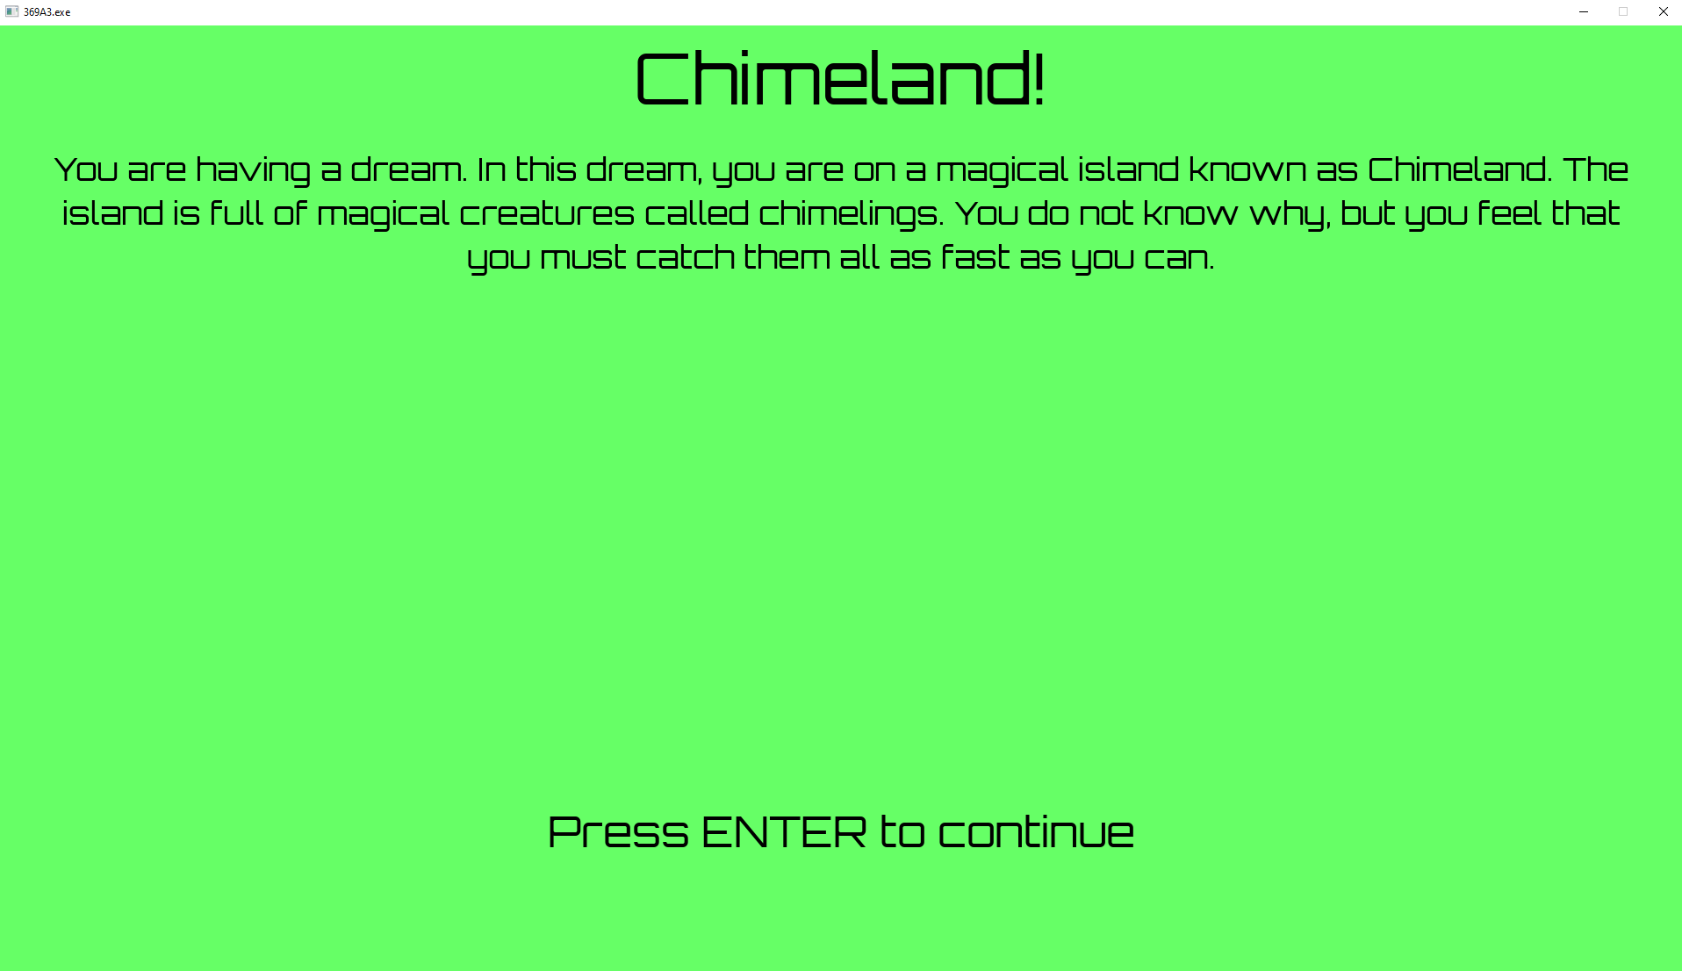

**Instructions page:**

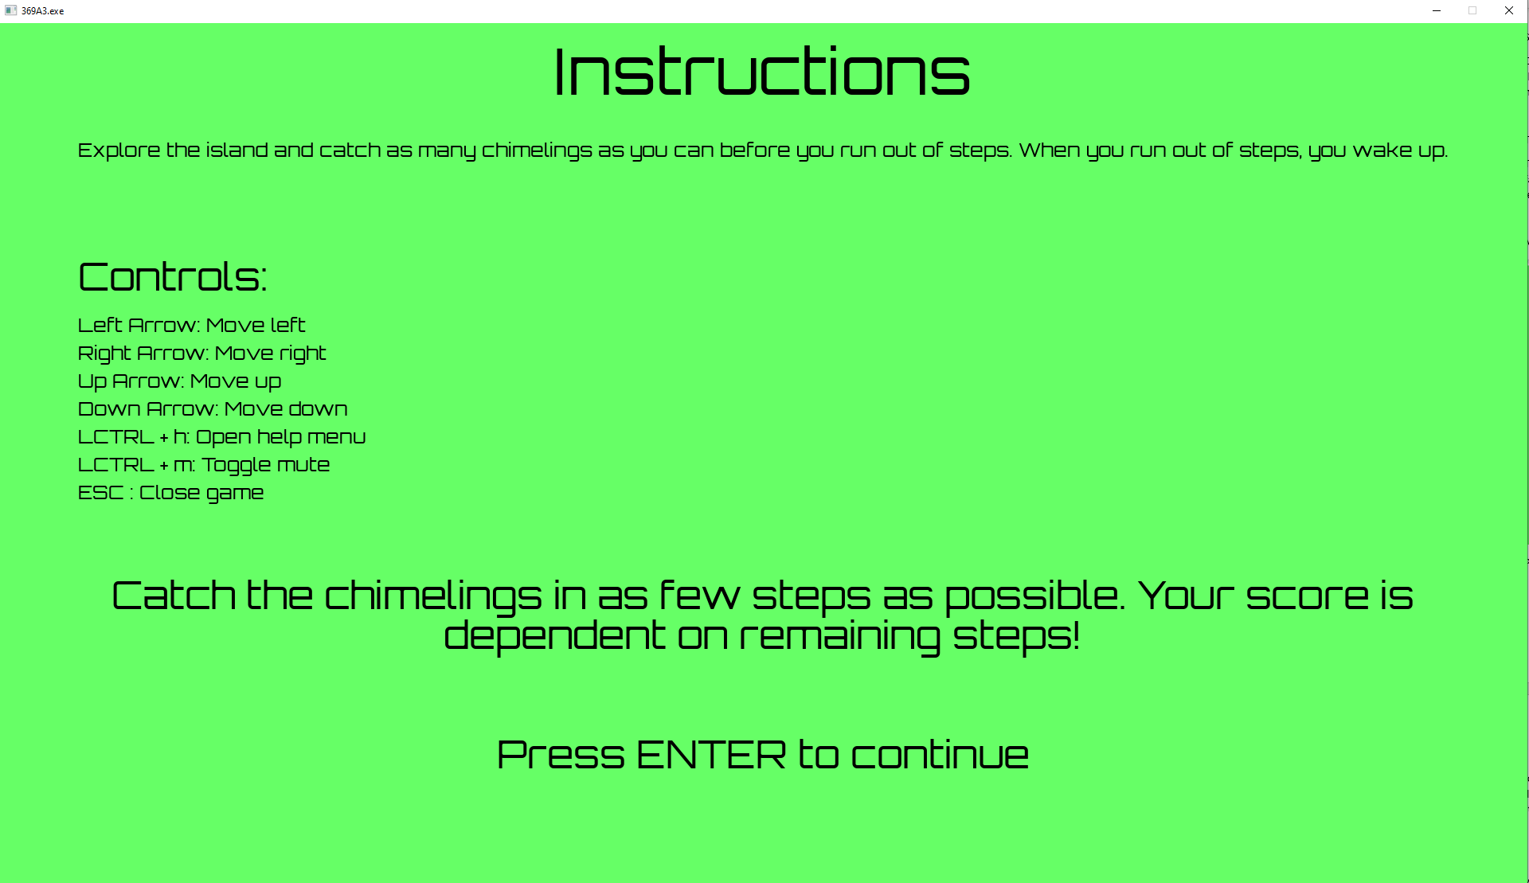

**Main game page:**

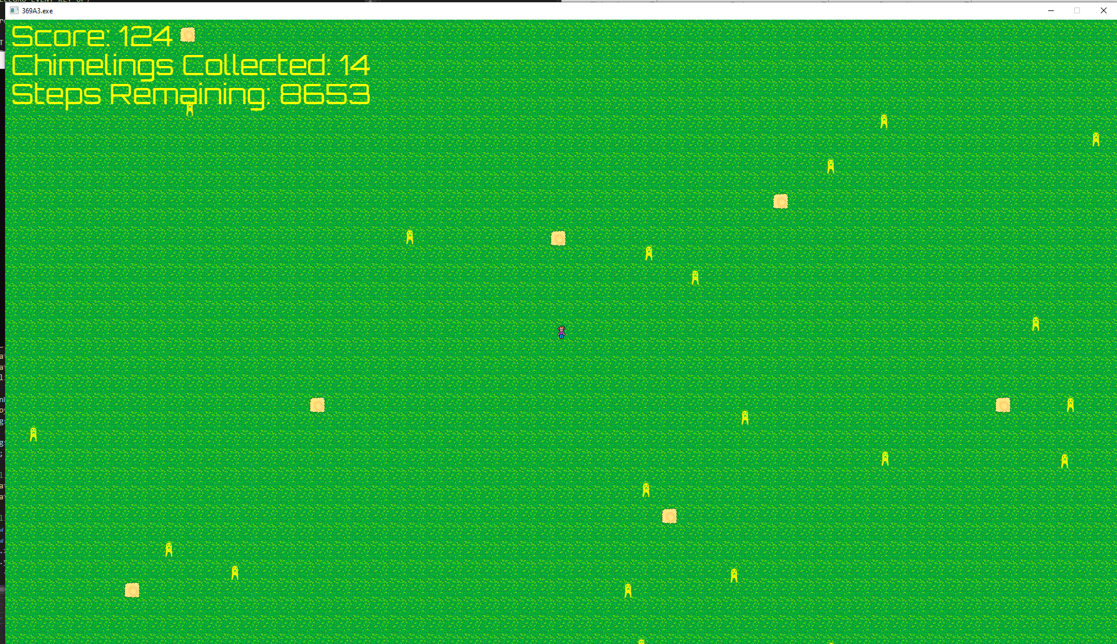

**Result Page:**

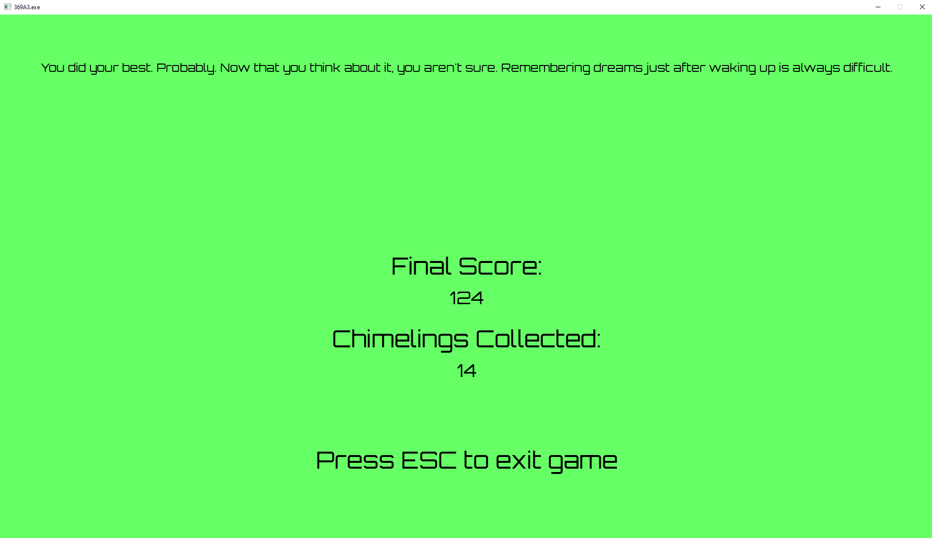

**Playing the Game**

Chimeland! Is very easy and intuitive to play. The player simply uses the arrow keys to move around and collect Chimelings. Additional controls are ESC to quit the game, LCTRL+H to open the instructions page, and LCTRL+M to mute the game.

**Artificial Intelligence Overview**

This revision of Chimeland! Employs some measure of artificial intelligence to make the game more immersive. Rather than have the chimelings just be static objects, chimelings are now fully animate. They move around from side to side, seemingly wiggling in place. The wiggling in place behaviour is deliberate. If a velocity-based movement was employed instead, then chimelings would become much harder for the player to track down, which would have been annoying for the player. In addition, since the game is step based rather than time based, if chimelings moved around the entire island, there is technically a chance that they would eventually all group up right next to the player. This would incentivise having the player wait for the optimal moment before moving, which is something I wanted to avoid. In addition, chimelings will actively avoid the player if they get too close by moving away to a safe distance.

**Characters and NPCs Description**

The player is the main character of this story. Because of this, the player sprite himself represents the actual player who is playing the game. As such, no backstory is given to the player, as to not break immersion.

The only other NPCs in this game are the Chimelings. These Chimelings do not move, and are just sitting there waiting for the player to collect them. As this game is supposed to represent a fleeting dream sequence, the Chimelings do not have an apparent reason for existing, much less a personality of their own.